

**UNIVERSITY INSTITUTE OF ENGINEERING**

**Department of Computer Science & Engineering**

# Subject Name: MOBILE APPLICATION DEVELOPMENT LAB

**Subject Code:** 20CSP-356

**Submitted to: Submitted by:**

Faculty name: Mr. Hemant Kumar Name: Sahil Kaundal

UID: 21BCS8197

Section: 616

Group: A

**INDEX**

|  |  |  |  |  |  |  |
| --- | --- | --- | --- | --- | --- | --- |
| **Ex. No** | **List of Experiments** | **Conduct (MM: 12)** | **Viva**  **(MM: 10)** | **Record (MM: 8)** | **Total**  **(MM: 30)** | **Remarks/Signature** |
| 1.1 | Installing and running applications on android studio |  |  |  |  |  |
| 1.2 | To design an android application to display Hello World |  |  |  |  |  |
| 1.3 | **Create Application by Using Widgets** |  |  |  |  |  |
| 2.1 |  |  |  |  |  |  |
| 2.2 |  |  |  |  |  |  |
| 2.3 |  |  |  |  |  |  |
| 2.4 |  |  |  |  |  |  |
| 3.1 |  |  |  |  |  |  |
| 3.2 |  |  |  |  |  |  |
| 3.3 |  |  |  |  |  |  |

**Experiment 1.3**

**Student Name:** Sahil Kaundal **UID:** 21BCS8197

**Branch:** CSE (Lateral Entry)  **Section/Group:** 616/A

**Semester:** 6th **Date of Performance:** 16/02/2023

**Subject Name:** Mobile Application Development Lab **Subject Code:** 20CSP-356

1. **Aim: Create Application by Using Widgets.**
2. **Objective: Create Application by Using Widgets.**

**Widgets** are the micro-version of the application that consists of some functionality of the application that is displayed only on the **Home Screens** or the **Lock Screen**. For example, we see **Weather**, **Time**, **Google Search Bars** on the Home Screen, and **FaceLock**, **FingerprintLock** on the Lock Screen, which are some of the Widgets available on the device. Widgets come along with the Application when you install it or download it from the Web. Generally, phones come with a manufacturing configuration but such elements can be adjusted by a user later in time.

1. **System Requirements:**

* Microsoft Windows 7/8/10 (32-bit or 64-bit)
* 4 GB RAM minimum, 8 GB RAM recommended (plus 1 GB for the Android Emulator)
* 2 GB of available disk space minimum, 4 GB recommended (500 MB for IDE plus 1.5 GB for Android SDK and emulator system image)
* 1280 x 800 minimum screen resolution
* Java JDK5 or later version
* Java Runtime Environment (JRE) 6 Android Studio

1. **Steps/Program:**

**Step 1: Create a New Project**

To create a new project in Android Studio please refer to [How to Create/Start a New Project in Android Studio](https://www.geeksforgeeks.org/android-how-to-create-start-a-new-project-in-android-studio/). We are implementing it for both Java and Kotlin languages.

**Step 2: Add the App Widget to the Project**

Right-Click on the app, move the cursor to new, find the “Widget” option at the end, select it.

Specify the required properties for the widget such as**min. width** and **height**, config file and preferred language, etc, and proceed. Files are automatically generated.

**Step 3: Install and Run the Code**

* Install and Run the code on Android Virtual Device (AVD) or a personal device.
* Open the widget section of the phone, lookup for a widget with the Application name, select it, bring it to the home screen.
* Try changing the dimensions and we are done!

During this selecting and deploying process, a few extra files are generated and minor changes are made to existing files as well. No programming is required for generating a basic widget and is only required if an application is to be embedded inside the widget, as discussed in the later parts of the article. Let us now explain the newly generated files the changes make to the existing ones, one by one.

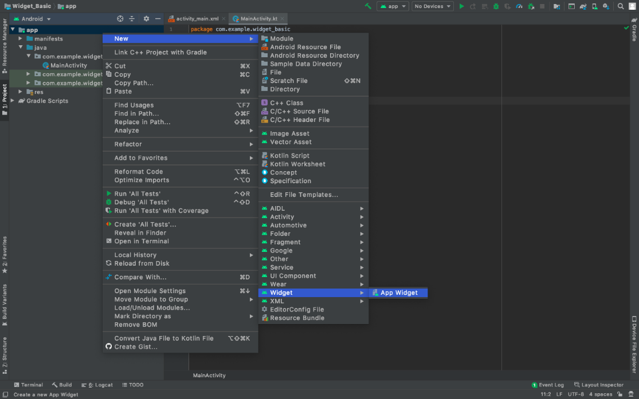

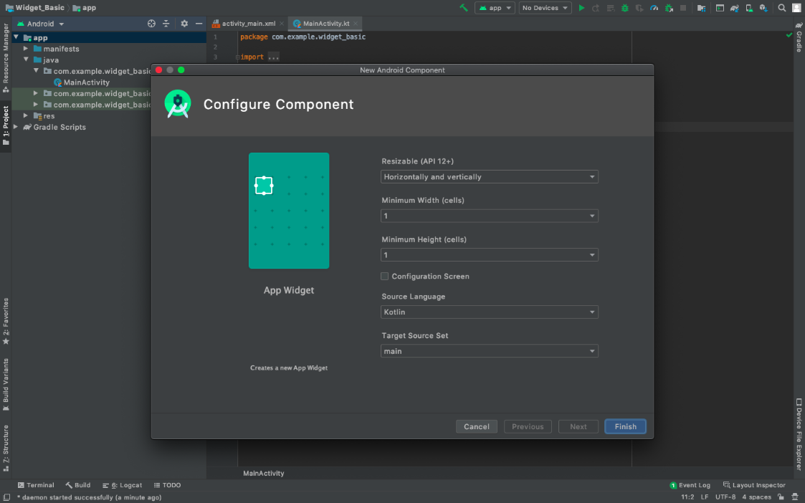

**1. NewAppWidget.kt**

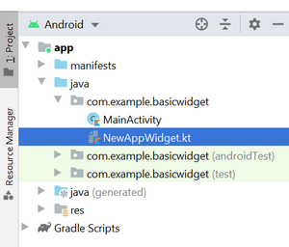

import android.appwidget.AppWidgetManager;

import android.appwidget.AppWidgetProvider;

import android.content.Context;

import android.widget.RemoteViews;

class NewAppWidget extends AppWidgetProvider {

@Override

public void onUpdate(Context context, AppWidgetManager appWidgetManager, int[] appWidgetIds){

for (int appWidgetId : appWidgetIds) {updateAppWidget(context, appWidgetManager, appWidgetId);

}

}

@Override public void onEnabled(Context context){

super.onEnabled(context);

}

@Override public void onDisabled(Context context){

super.onDisabled(context);

}private void

updateAppWidget(Context context, AppWidgetManager appWidgetManager, int appWidgetId)

{

String widgetText = context.getString(R.string.appwidget_text);

RemoteViews views = new RemoteViews(context.getPackageName(), R.layout.new_app_widget);

views.setTextViewText(R.id.appwidget_text, widgetText);

appWidgetManager.updateAppWidget(appWidgetId, views);

}}

**2. new_app_widget.xml**

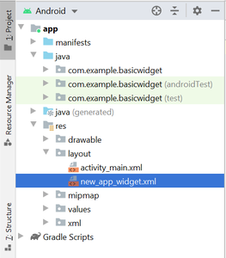

**<RelativeLayout**

**xmlns:android="http://schemas.android.com/apk/res/android"**

**android:layout_width="match_parent"**

**android:layout_height="match_parent"**

**android:background="#09C"**

**android:padding="@dimen/widget_margin">**

**<TextView**

**android:id="@+id/appwidget_text"**

**android:layout_width="wrap_content"**

**android:layout_height="wrap_content"**

**android:layout_centerHorizontal="true"**

**android:layout_centerVertical="true"**

**android:layout_margin="8dp"**

**android:background="#09C"**

**android:contentDescription="@string/appwidget_text"**

**android:text="@string/appwidget_text"**

**android:textColor="#ffffff"**

**android:textSize="24sp"**

**android:textStyle="bold|italic" />**

**</RelativeLayout>**

**3. dimens.xml**

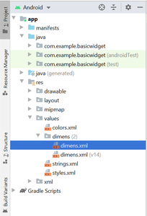

<?xml version="1.0" encoding="utf-8"?>

<resources>

<dimen name="widget_margin">8dp</dimen>

</resources>

**4. new_app_widget_info.xml**

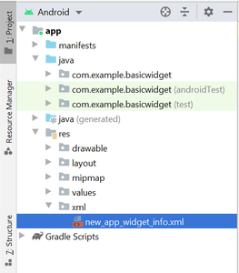

**<?xml version="1.0" encoding="utf-8"?>**

**<appwidget-provider**

**xmlns:android="http://schemas.android.com/apk/res/android"**

**android:initialKeyguardLayout="@layout/new_app_widget"**

**android:initialLayout="@layout/new_app_widget"**

**android:minWidth="40dp"**

**android:minHeight="40dp"**

**android:previewImage="@drawable/example_appwidget_preview"**

**android:resizeMode="horizontal|vertical"**

**android:updatePeriodMillis="86400000"**

**android:widgetCategory="home_screen">**

**</appwidget-provider>**

**5. Changes made to AndroidManifest.xml file**

<?xml version="1.0" encoding="utf-8"?>

<manifest xmlns:android="http://schemas.android.com/apk/res/android"

package="org.geeksforgeeks.widget_basic">

<application

android:allowBackup="true"

android:icon="@mipmap/ic_launcher"

android:label="@string/app_name"

android:roundIcon="@mipmap/ic_launcher_round"

android:supportsRtl="true"

android:theme="@style/AppTheme">

<receiver android:name=".NewAppWidget">

<intent-filter>

<action android:name="android.appwidget.action.APPWIDGET_UPDATE" /> </intent-filter>

<meta-data

android:name="android.appwidget.provider"

android:resource="@xml/new_app_widget_info" />

</receiver>

<!-- ----------------------------Until Here------------------------------------>

<activity android:name=".MainActivity">

<intent-filter>

<action android:name="android.intent.action.MAIN" />

<category android:name="android.intent.category.LAUNCHER" />

</intent-filter></activity></application></manifest>

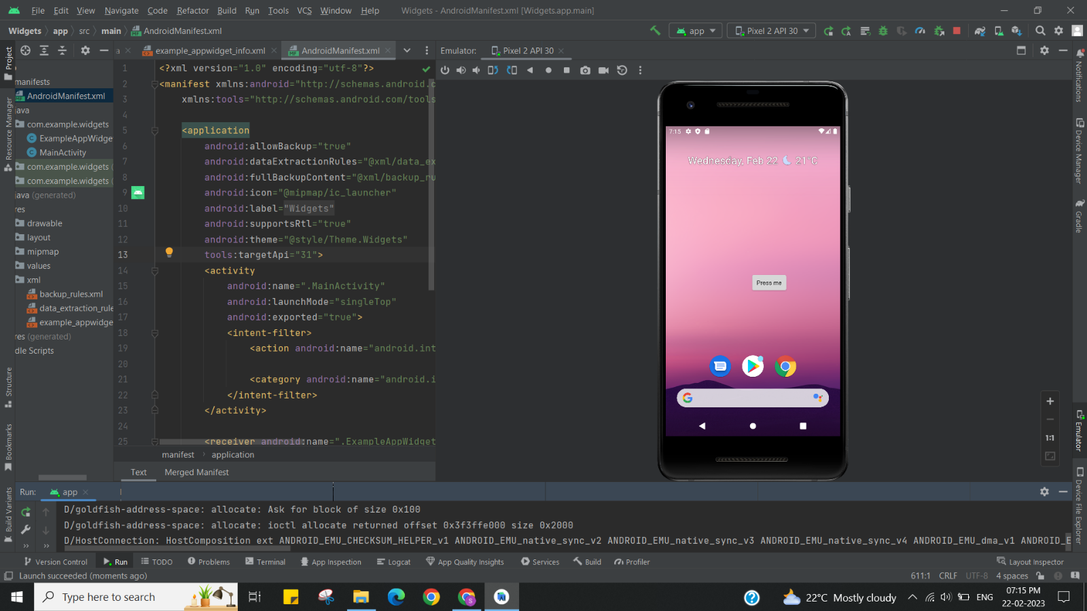

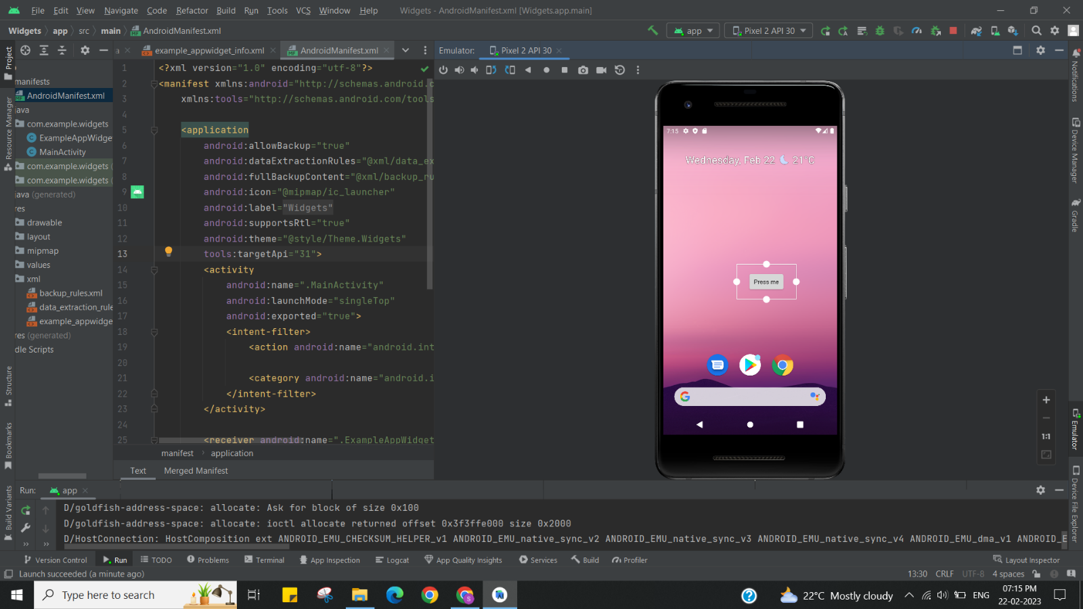

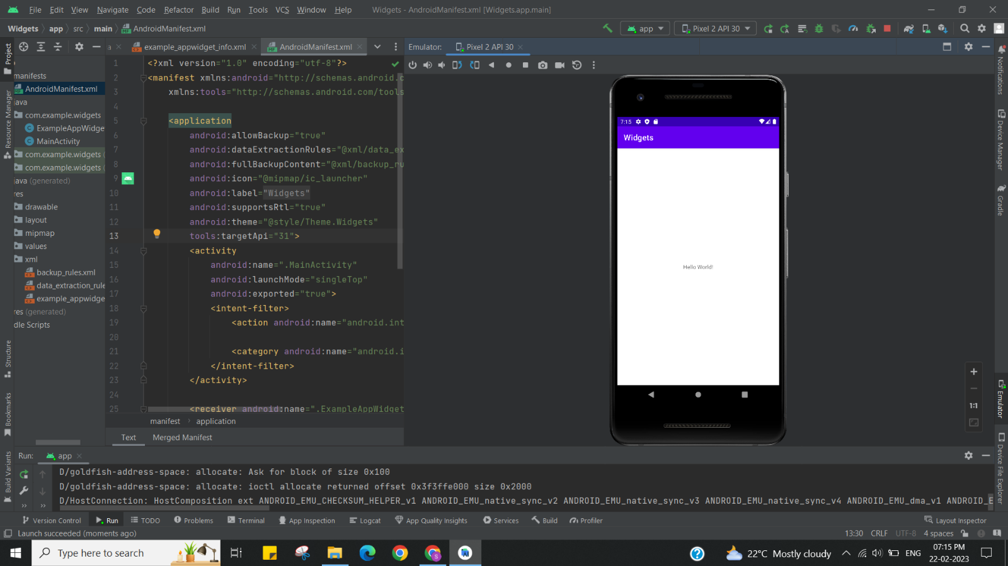

**Learning outcomes (What I have learnt):**

* To design an android application which uses widget in android studio.
* Learnt about running application on android studio.

**Evaluation Grid (To be created as per the SOP and Assessment guidelines by the faculty):**

|  |  |  |  |
| --- | --- | --- | --- |
| Sr. No. | Parameters | Marks Obtained | Maximum Marks |
| 1. |  |  |  |
| 2. |  |  |  |
| 3. |  |  |  |
|  |  |  |  |